**AI Solution for Industries**: Smart AI Traffic & Delivery Optimization System for Gauteng

We always hear about the "Fourth Industrial Revolution" a world where smart technology solves big problems. Our project, the **"Smart AI Traffic & Delivery System,"** is our way of bringing that future to Gauteng *today*. Instead of just talking about AI, we're building a practical, Python-powered assistant for the province's logistics, manufacturing, and retail sectors.

Think of it as a super-smart co-pilot for the entire supply chain. By using techniques like Machine Learning and real-time data analysis, our system takes the guesswork out of delivery routes. It turns information from traffic cameras and GPS trackers into clear, actionable advice, helping trucks avoid jams, save fuel, and get goods where they need to be, on time. This is a real-world AI solution built for local industry challenges, making it a perfect fit for the theme.

**Problem Definition:** Stuck in Traffic, Stuck in the Past

Gauteng is the beating heart of South Africa's economy, but its arteries are clogged. For businesses, traffic congestion isn't just a daily frustration – it's a direct hit to their bottom line. The current system is broken:

Trucks are burning money while standing still, wasting fuel and racking up maintenance costs.

Factories grind to a halt waiting for delayed parts, and store shelves run low because deliveries are stuck in jams.

Customers lose trust when promises are broken and deliveries are late.

We all know the N1 is a parking lot at 8 AM, but there's no smart system to proactively guide drivers around the chaos. We're always reacting, never getting ahead.

**How does fixing this help our community**?

When we solve this for businesses, everyone wins:

**Smoother roads for all**: By getting trucks onto smarter routes, we reduce congestion for every commuter.

**A cleaner, greener Gauteng**: Less idling and shorter routes mean cleaner air and a smaller carbon footprint for our province.

**A thriving local economy**: Reliable deliveries make Gauteng a better place to do business, attracting investment and creating jobs.

**Smarter city planning**: The data our system collects can help the municipality build better roads and plan for the future.

**Our Mission: Building a Smarter Way Forward**

Our main goal is to create an AI system that takes the stress out of logistics. We want to build a system that:

**Predicts traffic jams** before they happen, like a weather forecast for the roads.

**Plans the quickest and cheapest routes** for every delivery truck, every time.

**Instantly adapts when things change**, rerouting drivers around accidents or roadblocks in real-time.

**Talks to drivers and managers** in a simple, intuitive way, through a clean dashboard and a voice assistant.

**Poster:** Showing what our AI system is about

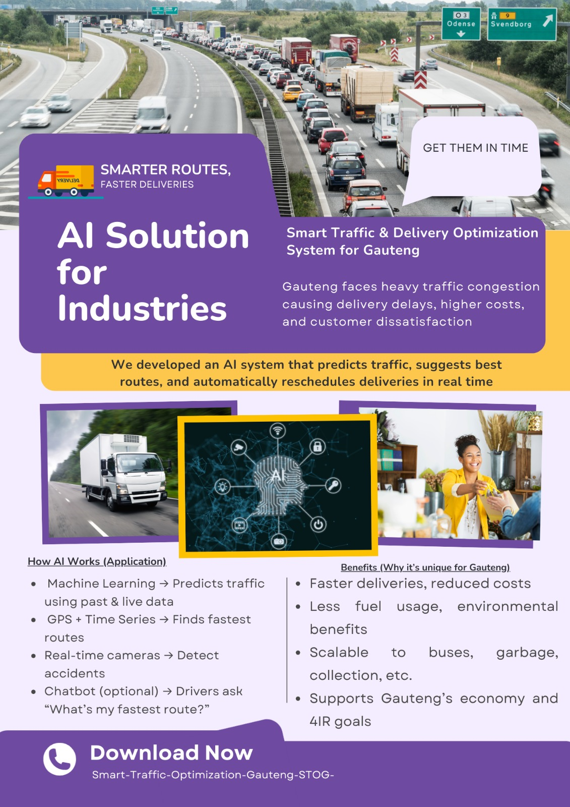

**Business Objectives**

* What We Want to Achieve:
* Get 95% of deliveries to arrive on time.
* Cut fuel bills by 15% for companies using our system.
* Shorten the average delivery time by a fifth.
* Give managers a live, crystal-clear view of their entire operation.

**How We'll Know It's Working:**

* Our traffic predictions will be **over 95% accurate.**
* Drivers and managers will give the system a **thumbs-up (4.5/5 rating or higher).**
* Companies will see a **clear return on their investment** within a year and a half.

**Business Success Criteria**

The traffic prediction model must achieve a Mean Absolute Error (MAE) of less than 5% on test data.

User satisfaction score from logistics managers and drivers must exceed 4.5 out of 5

The system must demonstrate a positive Return on Investment (ROI) for pilot companies within 18 months.

**Business Background**

Gauteng contributes over 35% to South Africa's GDP, yet its economic potential is throttled by a transport infrastructure operating beyond its capacity. Industries relying on "just-in-time" delivery are particularly vulnerable. The current approach to logistics is reactive; dispatchers use static maps and experience, not live, data-driven intelligence. This project seeks to bridge this technological gap, moving the local industry into a data-centric, AI-powered operational model.

**Requirements**

**Functional Requirements**:

* Ingest data from multiple sources: traffic APIs, GPS trackers, weather feeds, and user reports.
* Train, validate, and deploy machine learning models for prediction.
* Calculate and display optimal routes on a map-based dashboard.
* Send real-time alert notifications to drivers.
* Accept and process voice commands from drivers.

**Non-Functional Requirements**

* The system must process data and update routes with a latency of less than 2 minutes.
* The web dashboard must be accessible 99.9% of the time.
* All user and location data must be encrypted in transit and at rest.

**Constraints**

**Data Availability**: The project is dependent on the quality and accessibility of open and commercial traffic datasets.

**Computational Resources**: Real-time model inference and route calculation require significant processing power, which may constrain deployment options initially.

**Integration**: Seamless integration with existing Fleet Management Systems (FMS) used by companies may require developing custom API connectors.

**Risks**

**Technical Risk**: The AI models may not generalize well to unseen traffic conditions, leading to inaccurate predictions.

**Project Risk**: Delays in acquiring clean, reliable data from municipal sources could impact the development timeline.

**Business Risk**: Driver resistance to adopting a new, AI-driven system could hinder its effectiveness.

**Our Toolkit:**

We're building this with **Python**, the go-to language for AI, and a powerful set of tools:

* **Scikit-learn, Pandas, NumPy:** For the core data analysis and prediction engines.
* **TensorFlow & OpenCV:** For advanced image recognition from traffic cameras.
* **NLTK & SpeechRecognition:** To power the voice assistant for drivers.
* **Flask:** To build the web dashboard for managers.
* **GitHub:** To collaborate and manage our code as a team.

**Machine Learning Approach**

**Supervised Learning for Congestion Prediction**: We will frame traffic prediction as a regression problem (predicting traffic speed or volume) and a classification problem (predicting congestion level: Low, Medium, High). Algorithms like Random Forest and XGBoost are well-suited for the tabular data from sensors and GPS logs. They handle non-linear relationships well and provide feature importance, helping us understand which factors (e.g., time of day, day of week, weather) most impact congestion.

**Reinforcement Learning (RL) for Dynamic Routing**: For real-time adaptation, we will model the road network as a graph. An RL agent (using a algorithm like Q-Learning) will learn the optimal policy for moving from an origin to a destination. The "state" is the vehicle's current location and known traffic conditions, the "action" is the choice of the next road segment, and the "reward" is based on negative travel time. This allows the system to learn and improve its routing strategies over time, even in complex, changing environments.

**Unsupervised Learning for Pattern Discovery**: K-Means Clustering will be used to identify recurring traffic hotspots and patterns without prior labels. This can reveal previously unknown congestion zones or typical traffic flow profiles, which can be fed back into the supervised models to improve their accuracy.

**Data**

The AI models will be trained and operated on a variety of datasets:

**Historical Traffic Data**: Sourced from municipal databases or open data portals (e.g., Gauteng Traffic Data). This includes average speed, volume, and incident reports per road segment over time.

**Real-Time Data Feeds**: Ingested via APIs from services like Google Traffic API or TomTom Traffic API. This provides the live input needed for real-time prediction and re-routing.

**GPS Logs from Delivery Fleets**: Anonymized data from partner logistics companies, providing ground-truth data on actual travel times under various conditions.

**Weather Data**: Integrated from a service like OpenWeatherMap API, as weather is a significant confounding variable for traffic patterns.

**Traffic Camera Imagery**: Live feeds from municipal traffic cameras, which will be processed by computer vision models.

**Data Preprocessing**:

The pandas and sklearn.preprocessing libraries will be used extensively.

**Handling Missing Values**: Missing speed data will be imputed using the mean or median of that road segment at that specific time-of-day.

**Data Binarization**: Categorical variables like "weather condition" (sunny, rainy) will be converted to binary values.

**Data Normalization**: Numerical features like traffic volume and temperature will be scaled to a standard range (e.g., 0-1) using MinMaxScaler to ensure no single feature dominates the model training.

**Label Encoding**: Target labels like "Congestion Level" (Low, Medium, High) will be converted to numerical form using LabelEncoder.

**Model Evaluation**

We will use a robust set of metrics to evaluate our models, ensuring they are accurate and reliable before deployment.

For Regression Models (predicting traffic speed):

Mean Absolute Error (MAE): sklearn.metrics.mean_absolute_error

Root Mean Squared Error (RMSE): sklearn.metrics.mean_squared_error

R² Score: sklearn.metrics.r2_score

For Classification Models (predicting congestion level):

Confusion Matrix: To visualize True Positives, False Positives, etc.

Accuracy: (TP+TN)/Total

Precision and Recall: To handle any class imbalance in congestion events.

F1-Score: The harmonic mean of precision and recall.

We will use the train_test_split function from sklearn.model_selection to create training and testing sets, and K-Fold Cross-Validation to get a more generalized estimate of model performance.

**Time Series Analysis on Data**

We will use the pandas library to handle dates and times, resampling data into consistent intervals (e.g., 15-minute blocks).

**Analysis Technique**: We will employ Autoregressive Integrated Moving Average (ARIMA) models from the statsmodels library to capture the temporal dependencies (e.g., morning rush hour repeats daily). For more complex, long-term dependencies, we will use Long Short-Term Memory (LSTM) networks, a type of Recurrent Neural Network (RNN) available in Keras/TensorFlow, which are exceptionally good at learning from sequences of data.

**Sample Description**: A sample analysis would involve taking a month of historical speed data for the N1 highway, resampling it to hourly averages, and using an LSTM model to forecast the speed for the next 6 hours. The model would learn that speeds drop between 07:00-09:00 and 16:00-18:00 on weekdays but not on weekends.

**Solution Techniques**

**Dynamic Route Optimization**: The core routing algorithm will be a hybrid of A Search* (informed by the ML model's predictions which act as a heuristic) and Dijkstra's algorithm. The ML-predicted travel times for each road segment will be used as the "cost" for the algorithms to minimize.

**Ensemble Techniques**: To improve prediction accuracy and robustness, we will use Random Forest, which is itself an ensemble of decision trees. We may also explore stacking a GaussianNB model with a Logistic Regression model for the classification task.

**Model Accuracy Improvement**: The AI model's accuracy will be improved continuously through

**Hyperparameter Tuning**: Using GridSearchCV from sklearn to find the optimal model parameters.

**Feature Engineering**: Creating new input features, such as "is_public_holiday" or "hours_since_last_incident."

**Online Learning**: Implementing a feedback loop where drivers can confirm or deny route suggestions, using this new data to retrain and fine-tune the models periodically.

**Natural Language Processing, Speech Recognition or Speech Synthesis**

We will develop a voice-enabled assistant for drivers to ensure safe and hands-free interaction.

**Relevance**: This feature allows drivers to get route updates and report issues without taking their eyes off the road, directly enhancing the usability and safety of the solution.

Implementation:

**Speech Recognition**: The SpeechRecognition library will capture the driver's voice command (e.g., "What's my ETA?").

**NLP (NLTK):** Using nltk.tokenize and nltk.stem, the text will be processed. We will use a Bag of Words (BoW) model or a more advanced technique to classify the intent of the query.

**Response Generation**: The system will query the backend for the required information.

**Speech Synthesis**: Using a library like GTTS (Google Text-to-Speech), the system will convert the text response (e.g., "Your ETA is 14:35") back into speech for the driver.

We will utilize **Deep Learning** for two advanced capabilities:

**1.Computer Vision for Traffic Analysis**: Using Convolutional Neural Networks (CNNs) from the OpenCV and TensorFlow libraries, we will process live feeds from traffic cameras. The CNN will be trained to perform object detection (cars, trucks) and classification to detect incidents like stopped vehicles or accidents, providing a rich, real-time data source that complements the sensor data.

**2.Advanced Time Series Forecasting**: As mentioned, LSTM networks will be used for the most accurate long-term traffic forecasting, as they can remember patterns over long sequences, crucial for predicting the ripple effects of an accident.

A **rule-based and AI-enhanced chatbot** will be integrated into the web dashboard for logistics managers.

It will provide a natural language interface for non-technical users to query the system (e.g., "Show me all delayed deliveries," "What was our average fuel consumption last week?").

Setup: It will be built as a web application using Flask. The front-end will use JavaScript to capture user queries, which are sent to a Python backend. The backend will use the NLTK library for intent recognition and query the database to formulate a text or visual response (e.g., a chart) sent back to the dashboard.